Q. What is the string in c language?
A string is a sequence of characters terminated with a null character.
char c [] = "c string";
When the compiler encounters a sequence of characters enclosed in the double quotation marks, it appends a null character \0 at the end by default.
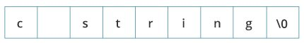
Q. How to declare a string?
Here's how you can declare strings:
char s[5];
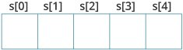
Here, we have declared a string of 5 characters.
Q. How to initialize strings?
You can initialize strings in a number of ways.
char c[] = "abcd";
char c[50] = "abcd";
char c[] = {'a', 'b', 'c', 'd', '\0'};
char c[5] = {'a', 'b', 'c', 'd', '\0'};
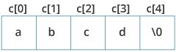
Let's take another example:
char c [5] = "abcde";
Here, we are trying to assign 6 characters (the last character is '\0') to a char array having 5 characters. This is bad and you should never do this.
Q. How to Assigning Values to Strings?
Arrays and strings are second-class citizens in C; they do not support the assignment operator once it is declared. For example
char c [100];
c = "C programming"; // Error! array type is not assignable.
Note: Use the strcpy() function to copy the string instead.
Q. how to read string from user?
You can use the scanf () function to read a string. The scanf () function reads the sequence of characters until it encounters whitespace (space, newline, tab, etc.).
Example 1: scanf () to read a string
#include <stdio.h>
int main()
{char name [20];
printf("Enter name: ");
scanf("%s", name);
printf("Your name is %s.", name);
return 0;
}
Input: Enter name: Dennis Ritchie
Output: Your name is Dennis.
Even though Dennis Ritchie was entered in the above program, only "Dennis" was stored in the name string. It's because there was a space after Dennis. Also notice that we have used the code name instead of &name with scanf().
scanf("%s", name);
This is because name is a char array, and we know that array names decay to pointers in C. Thus, the name in scanf() already points to the address of the first element in the string, which is why we don't need to use &.
Q. how to read line of text or string input with space?
How to read a line of text?
You can use the gets() function to read a line of string. And, you can use puts() to display the string
Example: gets() and puts()
#include <stdio.h>
int main()
{ char name[30];
printf("Enter name: ");
gets(name); // read string
printf("Name: ");
puts(name); // display string
return 0;
}
Input: Enter name: Tom Hanks
Output: Name: Tom Hanks
Here, we have used gets() function to read a string from the user.
Q. Passing Strings to Functions?
#include <stdio.h>
void displayString(char str[]);
int main()
{ char str[50];
printf("Enter string: ");
gets(str);
displayString(str); // Passing string to a function.
return 0;
}
void displayString(char str[])
{ printf("String Output: ");
puts(str);
}
You can pass the base address of string to the function and define the character pointer in function definition for accessing the string as parameter in function.

#include <stdio.h>
void displayString(char str[]);
int main()
{ char str[50];
printf ("Enter string: ");
gets (str);
displayString (str); // Passing base address to string
return 0;
}
void displayString(char *str)
{ printf("String Output: ");
puts(str);
}
Q. how to access the string by using a pointer?
If we want to access the string by using a pointer we have to store the base address of string in to the pointer and we can travel the string by using pointer and access the data from string using dereferencing technique i.e. by using * with pointer shown in following Example
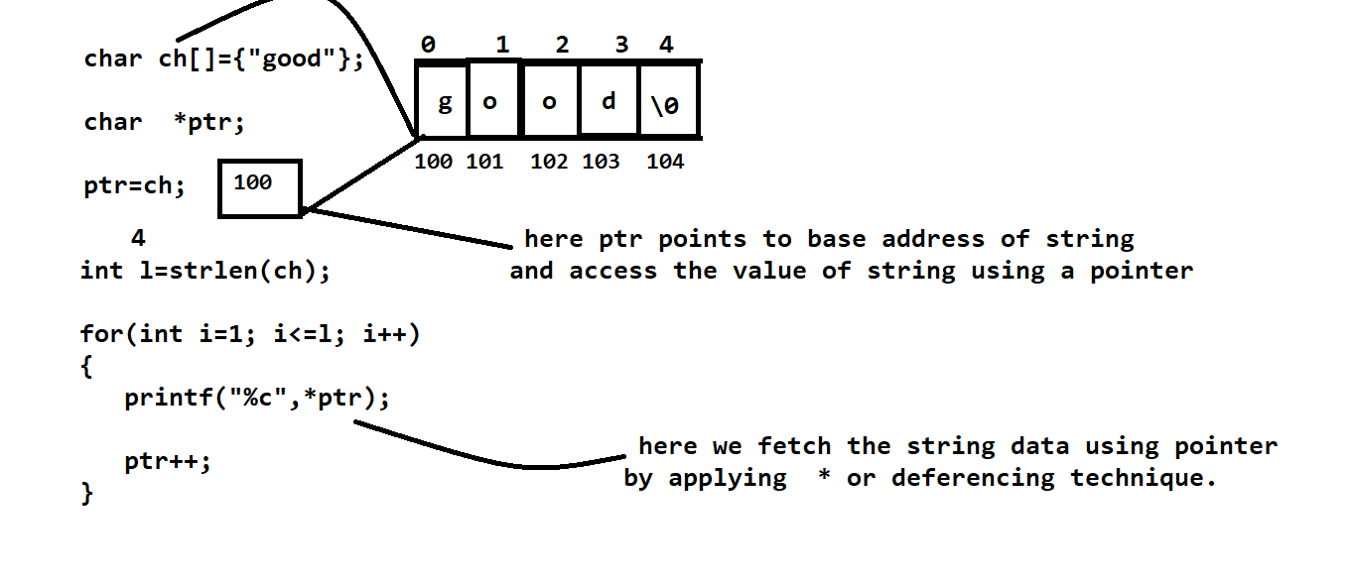

Q. how to return the string from a function?
If we want to return the string from a function we have to return the base address of string from function definition and catch the base address of string at function calling and use the same string at calling point of function.
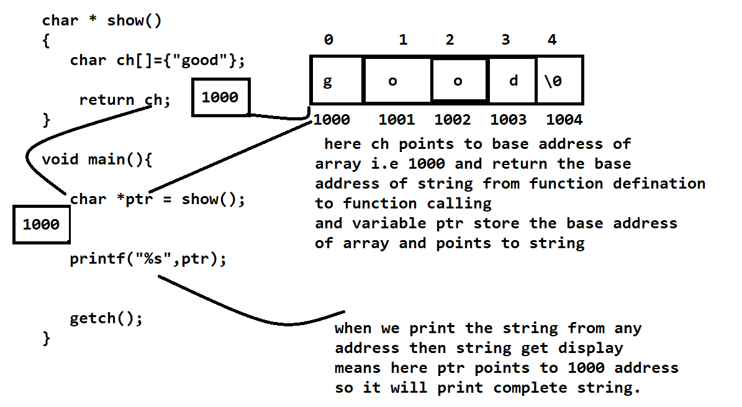

Q. explains the string handling functions in c language?
C language provides the some inbuilt functions to us for work with string shown below.
1) int strlen(char[]): this function is used for calculate the length of string.
#include<stdio.h>
#include<string.h>
#include<conio.h>
void main()
{ clrscr();
char ch[90];
printf("Enter the string\n");
gets(ch);
int l=strlen(ch);
printf("Length of string is %d\n",l);
getch();
}
2) strcpy(char[],char[]): this function is used for copy the right hand string in to the left hand string means copy the content of one string to another string in c language.
#include<stdio.h>
#include<string.h>
#include<conio.h>
void main()
{ clrscr();
char ch[90],ch1[90];
printf("Enter the first string\n");
gets(ch);
printf("Enter the second string\n");
gets(ch1);
printf("Before copy %s\n",ch);
strcpy(ch,ch1);
printf("After copy %s\n",ch);
getch();
}
In the above example we copy the content of ch1 in to the ch
3) strcat (char [], char []): this function is used for concat the content of one string with another string.
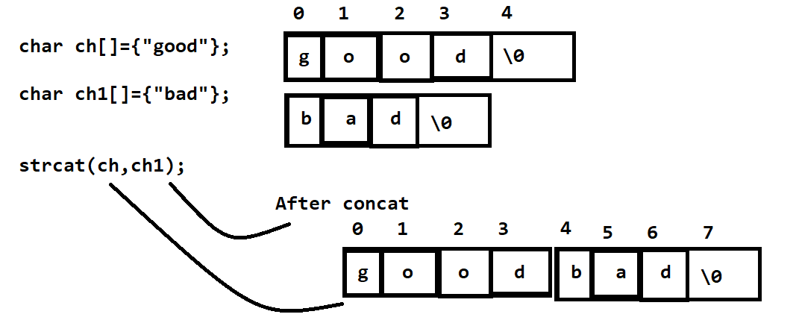

4) strcmp(char[],char[]): this function is used for compare the two strings with each other and return 0 if strings are equal and return the first mismatch ascii code difference if strings are not equal.
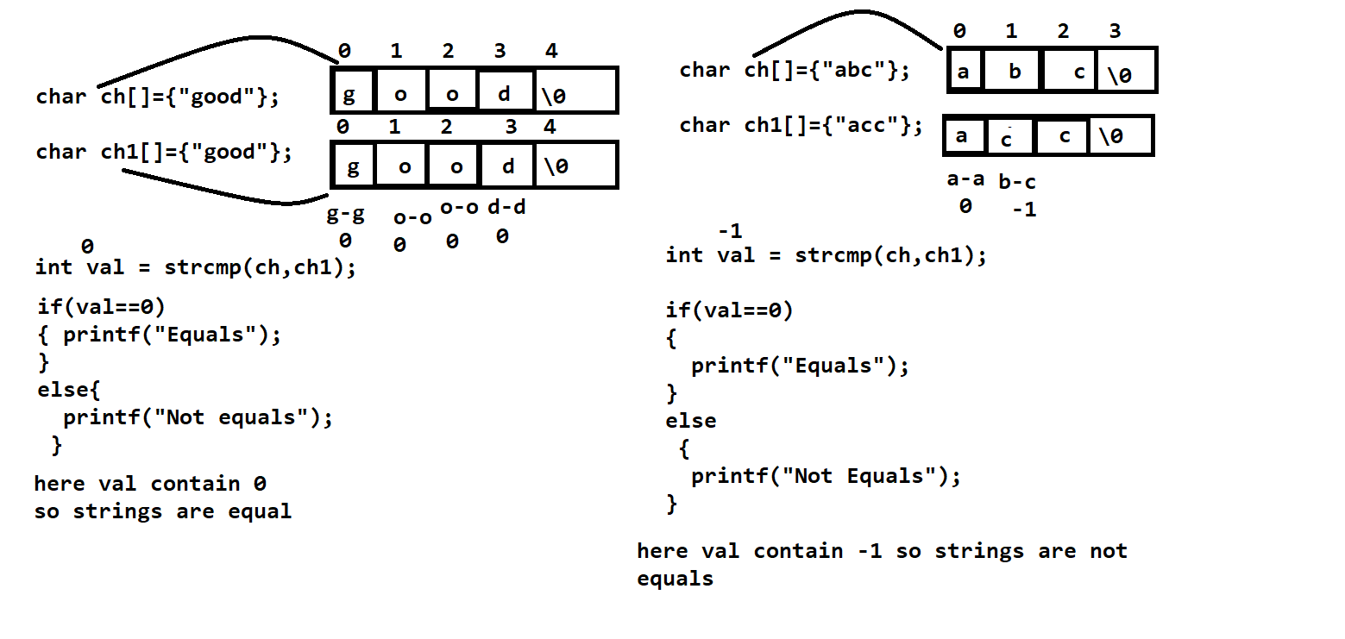
Q. Explain Two Dimensional Strings in detail?
two dimensional string is used for to create the multi line textual content means if we want to store the more than one line of statement programmatically we have the option is two dimensional string.
Following Diagram shows the two dimensional string with its explanation
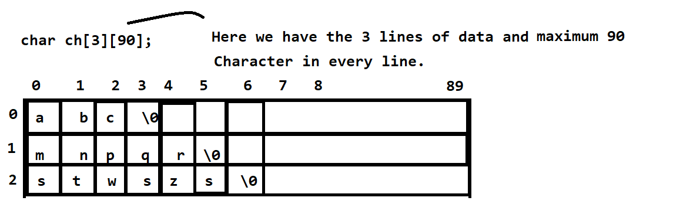

Following Code Demonstrate the two dimensional string
#include<stdio.h>
#include<conio.h>
void main()
{ char ch[5][90];
clrscr();
printf("Enter the strings\n");
for (int i=0; i<5; i++)
{ gets(ch[i]);
}
printf ("display the all string lines\n");
for (i=0; i<5; i++)
{ puts (ch[i]);
}
getch();
}

MCQ on String Handling
Q. what will be the output of given code?
#include<stdio.h>
#include<conio.h>
int main()
{ char ch[]={"good"};
char *ptr;
ptr=ch;
printf("%s",ptr);
return 0;
}

Q. what will be the output of given code?
#include<stdio.h>
#include<conio.h>
int main()
{ char ch[]={"good"};
char *ptr;
ptr=ch;
ptr=ptr+2;
printf("%s",ptr);
return 0;
}
Q. what will be the output of given code?
#include<stdio.h>
#include<conio.h>
int main()
{ char ch[]={"good"};
void show(char *);
show(ch);
printf("%s",ch);
return 0;
}
void show(char *ptr){
*ptr='m';
}
Q. what will be the output of given code?
#include<stdio.h>
#include<conio.h>
void main()
{ static char s[ ] = "Rendezvous!";
printf ("%d", *( s + strlen (s))) ;
getch();
}
Q. what will be the output of given code?
#include<stdio.h>
#include<conio.h>
void main()
{
char ch[20];
int i;
for(i = 0;i<19;i++ )
*( ch + i) = 67;
*(ch + i) = '\0';
printf ("%s", ch) ;
getch();
}
Q. what will be the output of given code?
#include<stdio.h>
#include<conio.h>
void main()
{
char str[20];
int i;
for(i = 0;i<=18;i++ )
i[str] = 'C ;
i[str] = \0';
printf ("%s", str);
}
Q. what will be the output of given code?
#include<stdio.h>
#include<conio.h>
void main()
{ char str[20];
static int i;
for (;;)
{ i++[str] = 'A' + 2 ,
if(i==19)
break;
}
i[str] = '\0';
printf ("%s", str);
getch();
}
Q. what will be the output of given code?
#include<stdio.h>
#include<conio.h>
void main()
{ static char str[ ] = {48,48,48,48,48,48,48,48,48,48};
char*s;
int i;
s = str;
for (i = 0 ; i <= 9 ; i++)
{ if(*s)
printf ("%c ",*s) ;
s++;
}
getch();
}
Q. what will be the output of given code?
#include<stdio.h>
#include<conio.h>
void main()
{ static char str[10] = {0,0,0,0,0,0,0,0,0,0};
char *s;
int i;
s = str;
for (i = 0 ; i <= 9 ; i++) {
if(*s )
printf ("%c",*s);
s++;
}
getch();
}
Q. what will be the output of given code?
#include<stdio.h>
#include<conio.h>
void main()
{ static char s[ ] = "C smart!!";
int i;
for (i = 0 ; s[i]; i++)
printf ("%c %c %c %c\n", s[i], *( s + i) , i[s], *( i + s) ;
getch();
}
Q. what will be the output of given code ?
#include<stdio.h>
#include<conio.h>
void main()
{ static char s[ ] = "Oinks Grunts and Guffaws";
printf ("%c\n",*(&s[2]));
printf ("%s\n",s +5) ;
printf ("%s\n",s):
printf ("%c\n",*(s +2)) ;
printf ("%d\n",s);
getch();
}

Q. what will be the output of given code?
#include<stdio.h>
#include<conio.h>
void main()
{ static char s[251 = The cocaine man";
int i = 0 ;
char ch;
ch = s[++i];
printf ("%c%d\n", ch,i);
ch = s[i++];
printf ("%c %d\n", ch,i);
ch = i++[s];
printf ("%c%d\n", ch, i) ;
ch = ++i[s] ;
printf ("%c%d\n", ch.i);
getch();
}
Q. what will be the output of given code?
#include<stdio.h>
#include<conio.h>
void main()
{ static char arr[ ] = "Pickpocketing my peace of mind.."
int i;
printf ("%c\n",*arr);
arr++;
printf ("%c\n",*arr)
getch();
}

Q.what will be the output of given code?
#include<stdio.h>
#include<conio.h>
void main()
{ static char str[ ] = "Limericks";
char*s;
s = &str[6] - 6 ;
while (*s)
printf ("%c", *s++);
getch();
}
Q. what will be the output of given code?
#include<stdio.h>
#include<conio.h>
void main()
{ static char s[ ] = "C it for yourself;
int i = 0 ;
while (s[i])
{
if(s[i]!=' ')
s[i] = s[i] + i ;
i++;
}
printf ("%s",s);
getch();
}
Q. what will be the output of given code?
#include<stdio.h>
#include<conio.h>
void main(){ clrscr();
static char str[ ] = "For your eyes only",
int i;
char *p;
for (p = str, i = 0 ; p + i <= str + strlen (str); p++, i++)
printf ("%c", *( p + i)) ;
getch();
}
Q. what will be the output of given code?
#include<stdio.h>
#include<conio.h>
void main()
{ static char str[ ] = "MalayalaM";
char *s;
s = str + 8 ;
while (s >= str)
{ printf ("%c",*s);
s--;
}
getch();
}
Q. what will be the output of given code?
#include<stdio.h>
#include<conio.h>
void main()
{ static char a[ ] = "Able was I ere I saw elbA";
char *t, *s, *b;
s = a ;
b = a + strlen (a ) -1 ;
t = b;
while (s != t)
{ printf ("%c",*s);
s++;
printf ("%c",*t);
t--;
}
getch ();
}

Programming Algorithm

